INSTITUTE OF ENGINEERING

ADVANCED COLLEGE OF ENGINEERING & MANAGEMENT

KUPONDOLE, LALITPUR

*(AFFILIATED TO TRIBHUVAN UNIVERSITY)*



LAB REPORT

LAB NO: 05

SUBJECT: DSAP

|  |  |
| --- | --- |
| SUBMITTED BY:  NAME: SAMEEP DHAKAL  ROLL NO: ACE074BCT063  DATE: 2021/08/06 | SUBMITTED TO:  DEPARTMENT OF COMPUTER AND ELECTRONICS |

**TITLE:** DESIGNN OF IIR DIGITAL FILTERS

**OBJECTIVE:** To design and observe IRR filters

**THEORY:**

IIR filters are digital filters with infinite impulse response. Unlike FIR filters, they have the feedback (a recursive part of a filter) and are known as recursive digital filters therefore. Block diagrams of FIR and IIR filters

For this reason IIR filters have much better frequency response than FIR filters of the same order. Unlike FIR filters, their phase characteristic is not linear which can cause a problem to the systems which need phase linearity. For this reason, it is not preferable to use IIR filters in digital signal processing when the phase is of the essence.

Otherwise, when the linear phase characteristic is not important, the use of IIR filters is an excellent solution.

There is one problem known as a potential instability that is typical of IIR filters only. FIR filters do not have such a problem as they do not have the feedback. For this reason, it is always necessary to check after the design process whether the resulting IIR filter is stable or not.

IIR filters can be designed using different methods. One of the most commonly used is via the reference analog prototype filter. This method is the best for designing all standard types of filters such as low-pass, high-pass, band-pass and band-stop filters.

**LAB TASK:**

1. **H(s)=(s+0.1)/((s+0.1) 2 +9)**
   1. **Impulse invariance**
      1. Convert the analog filter into a digital IIR filter by means of impulse invariance method.
      2. the frequency response in s-domain and z-domain.
      3. Plot the impulse response of the LTI model.
      4. Plot the impulse response in z-domain.

clc;

clear all;

close all;

b= [1 .1];

a= [1 .2 9 .01];

figure;

freqs(b,a);

title('Frequency response plot/ Sameep Dhakal/563');

figure;

subplot(4,1,1);

impulse(b,a);

title('Impulse response plot/ Sameep Dhakal/563');

[bz,az]= impinvar(b,a,2);

subplot(4,1,2);

dimpulse(bz,az);

[bz,az]= impinvar(b,a,10);

subplot(4,1,3);

dimpulse(bz,az);

[bz,az]= impinvar(b,a,20);

subplot(4,1,4);

dimpulse(bz,az);

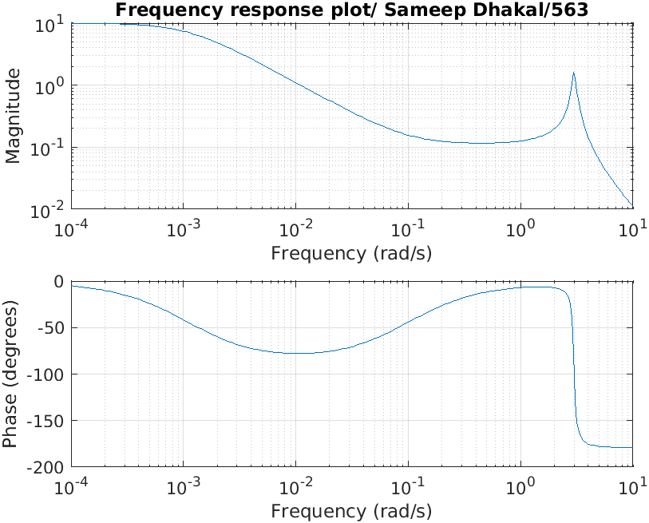

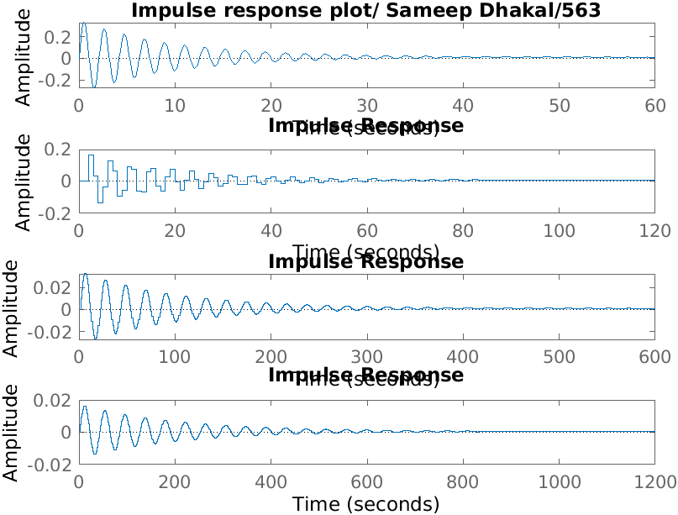

* 1. **Bilinear Transformation**
     1. Convert the analog filter into a digital IIR filter by means of bilinear transformation method.
     2. Plot the frequency response of the transformed filter by bilinear transformation
     3. Plot the impulse response in z-domain.
     4. Plot the step response of the LTI model.
     5. Step response of discrete time linear systems.

clc;

clear all;

close all;

b= [1 .1];

a= [1 .2 9 .01];

[bz,az]= bilinear(b,a,2);

freqs(bz,az);

title('frequency response by bilinear transformation/ Sameep Dhakal/563');

figure;

dimpulse(bz,az);

title('impulse response plot in z- domain/ Sameep Dhakal/563');

figure;

sys=tf(b,a);

step(sys);

title('step response plot of LTI system/ Sameep Dhakal/563');

figure;

dstep(bz,az);

title('step response plot for discrete time linear system/ Sameep Dhakal/563');

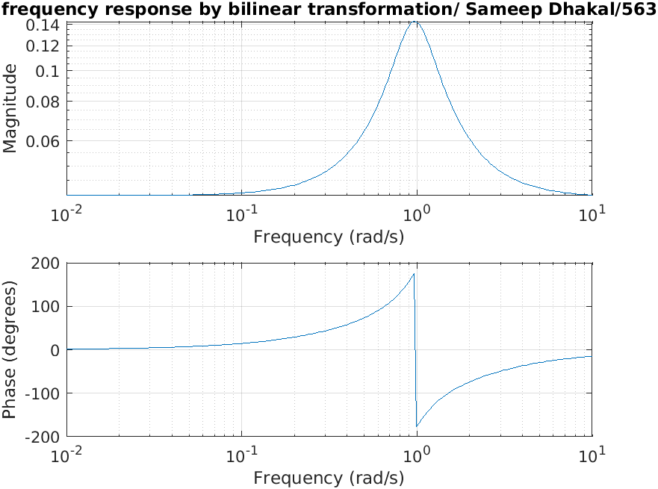

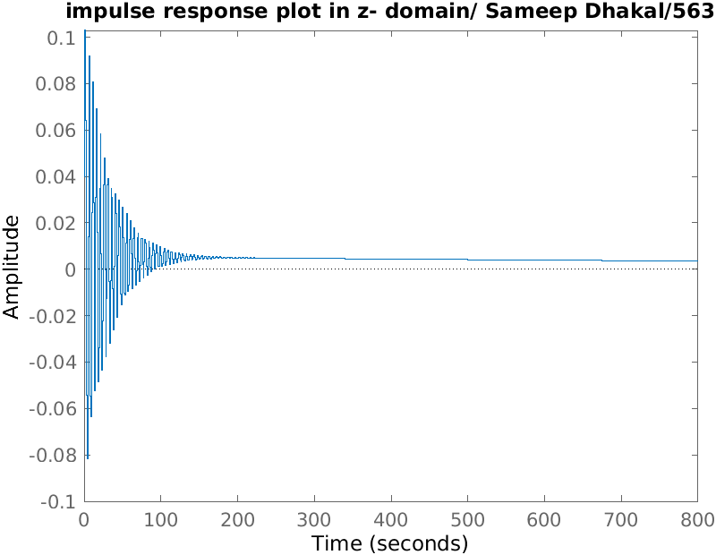

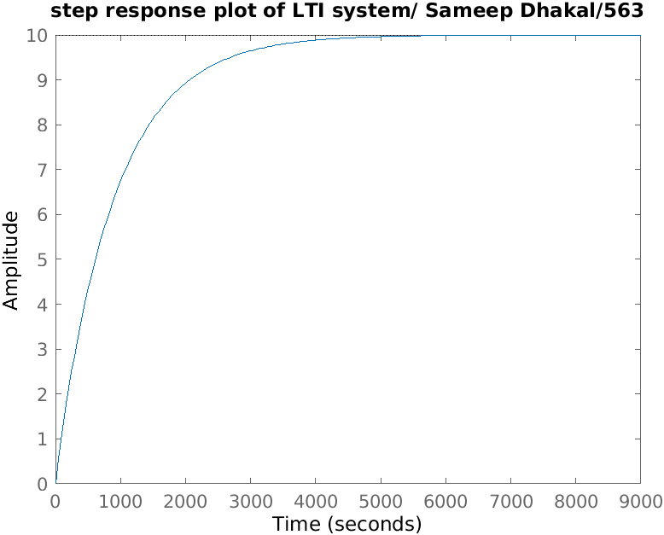

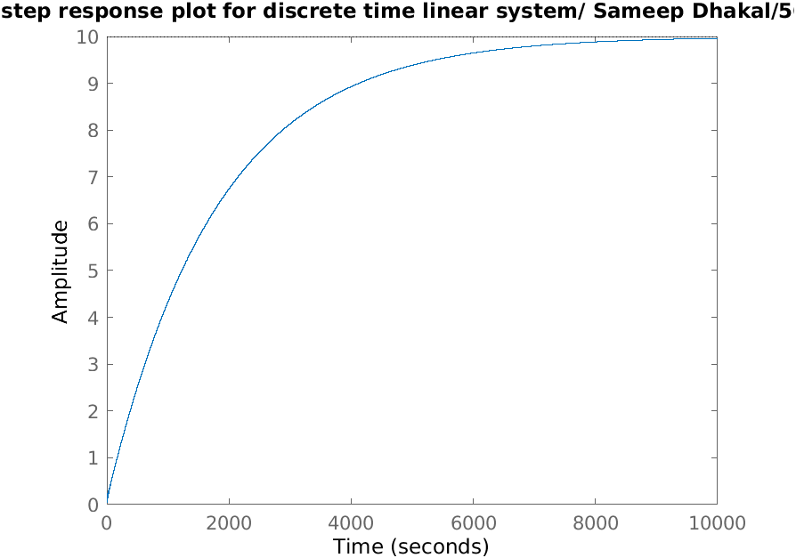

1. **Design of Butterworth Lowpass Filter**

An IIR digital low pass filter is required to meet the following specifications:

Pass band attenuation≤ dB

Stop band attenuation≤30 dB

Passband edge=400 Hz

Stopband edge=800Hz

Sample rate=2 KHz

* 1. Find its order.
  2. Plot its frequency response.
  3. Plot its poles and zeros.
  4. Plot its impulse response.
  5. Convert this filter into digital IIR filter by means of impulse invariance method.
  6. Plot the frequency response in z-domain.
  7. Plot the impulse response in z-domain
  8. Step response of the discrete time linear system

clear all;

close all;

wp= 400/2000;

ws= 800/2000;

rp= 4;

rs= 30;

[n,wn]= buttord(wp,ws,rp,rs);

[b,a]= butter(n,wn);

sys= tf(b,a);

figure;

freqs(b,a);

title('frequency response/ Sameep Dhakal/563');

figure;

pzmap(sys);

title('poles and zeros/ Sameep Dhakal/563');

figure;

impulse(b,a);

[bz,az]= impinvar(b,a,10);

figure;

dimpulse(bz,az);

figure;

dstep(bz,az);

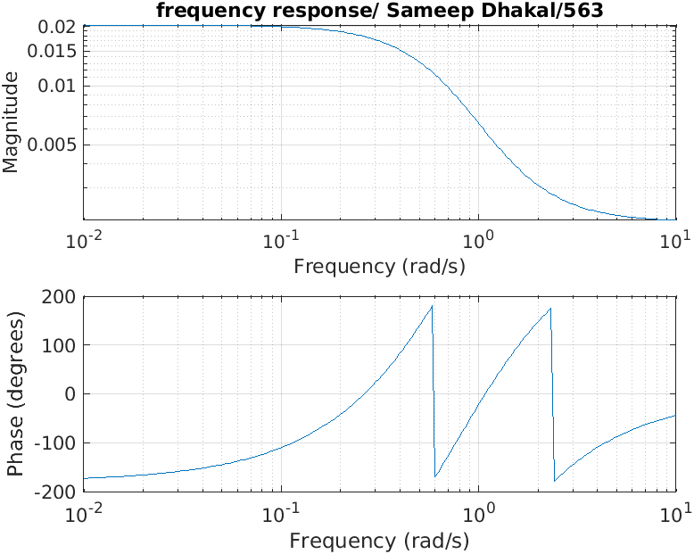

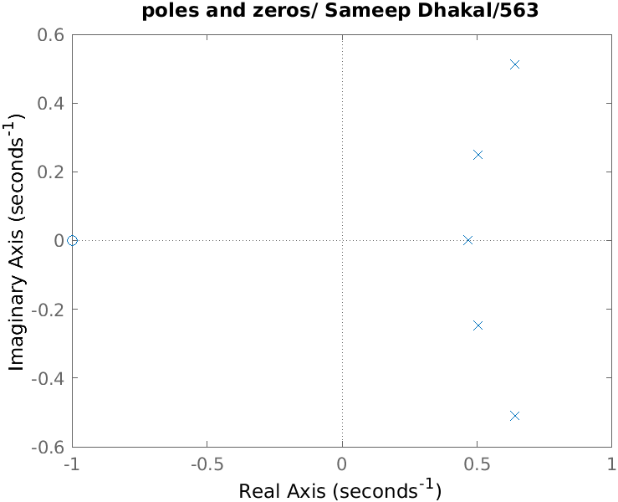

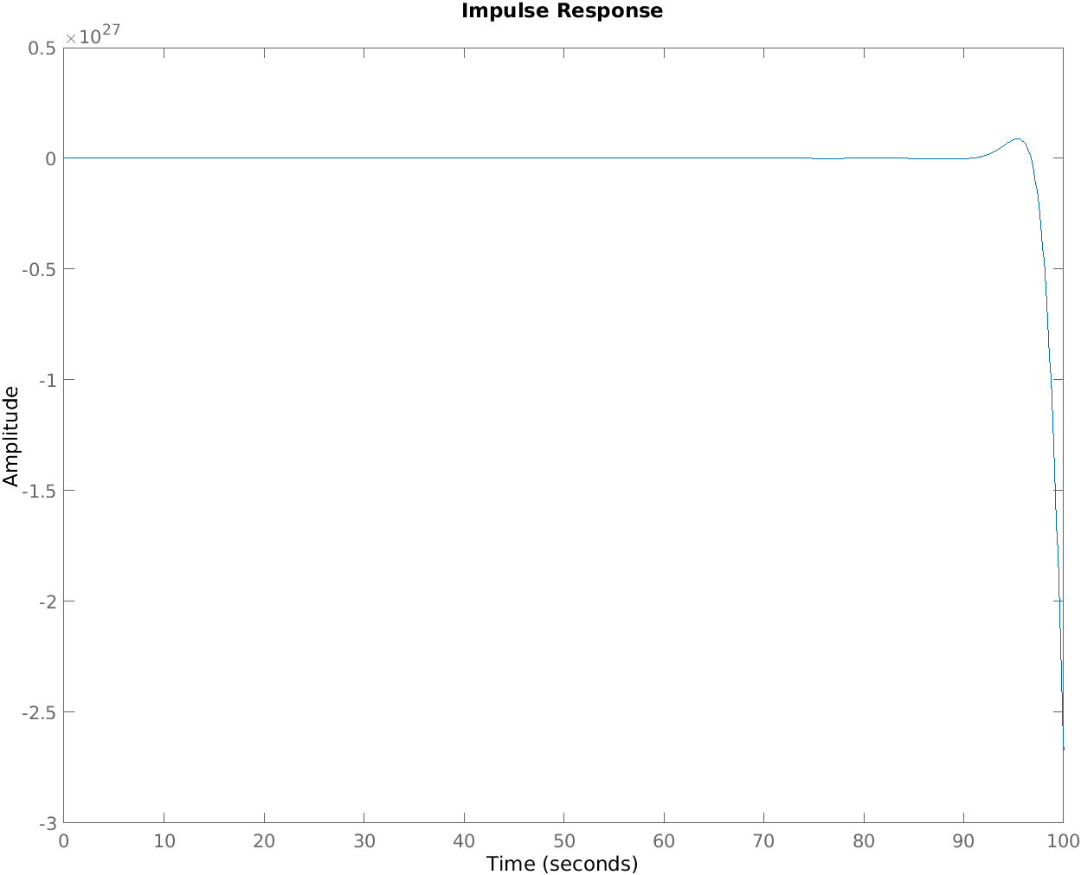

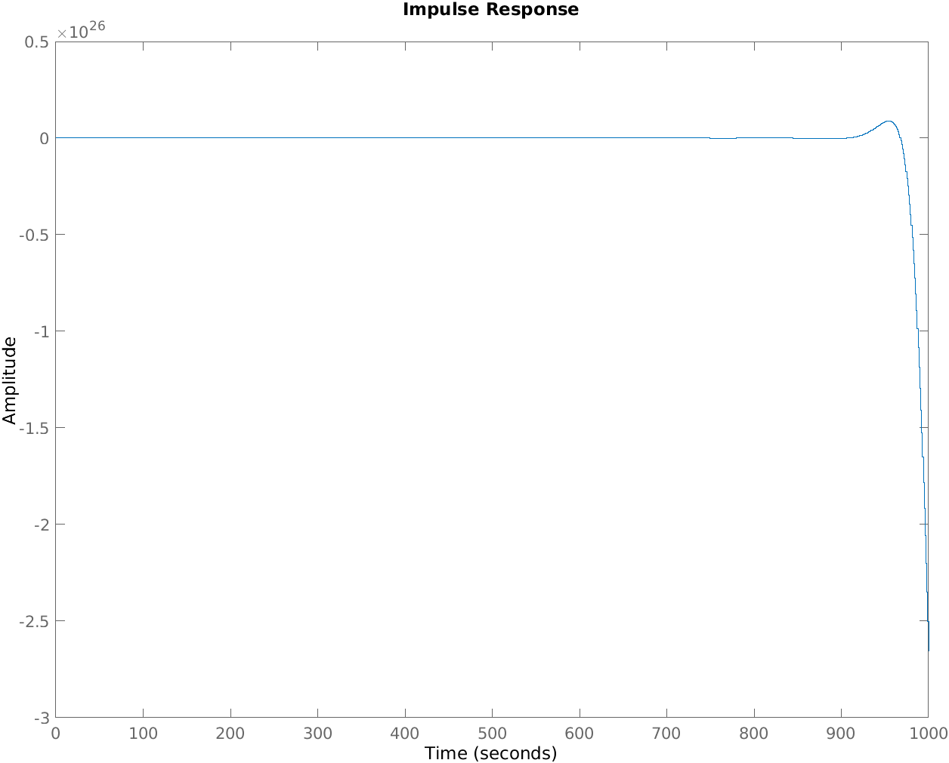

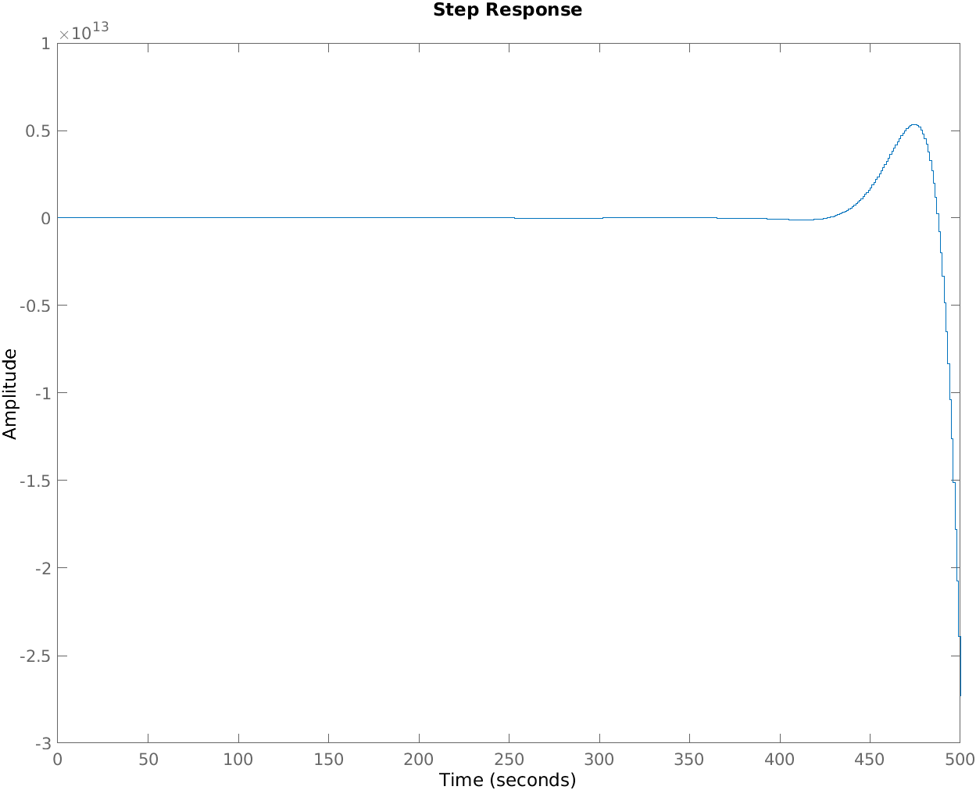

1. **Design of Chebyshev I and II Low Pass Filter**

Passband attenuation≤1dB

Stopband attenuation≤15dB

Passband edge frequency=0.2π rad/sec

Stopband edge frequency=0.3π rad/sec

* 1. Find its order.
  2. Plot its frequency response.
  3. Plot its poles and zeros.
  4. Plot its impulse response.
  5. Convert this filter into digital IIR filter by means of impulse invariance method.
  6. Plot the frequency response in z-domain.
  7. Plot the impulse response in z-domain
  8. Step response of the discrete time linear system

1. **Chebyshev I**

clc;

clear all;

close all;

wp= 0.2*pi;

ws=0.3*pi;

rp= 1;

rs= 15;

[n,wn]= cheb1ord(wp,ws,rp,rs);

[b,a]= cheby1(n,rp,wn);

sys= tf(b,a);

figure;

freqs(b,a);

title('frequency response/ Sameep Dhakal/563');

figure;

pzmap(sys);

title('poles and zeros/ Sameep Dhakal/563');

figure;

impulse(b,a);

[bz,az]= impinvar(b,a,10);

figure;

dimpulse(bz,az);

figure;

dstep(bz,az);

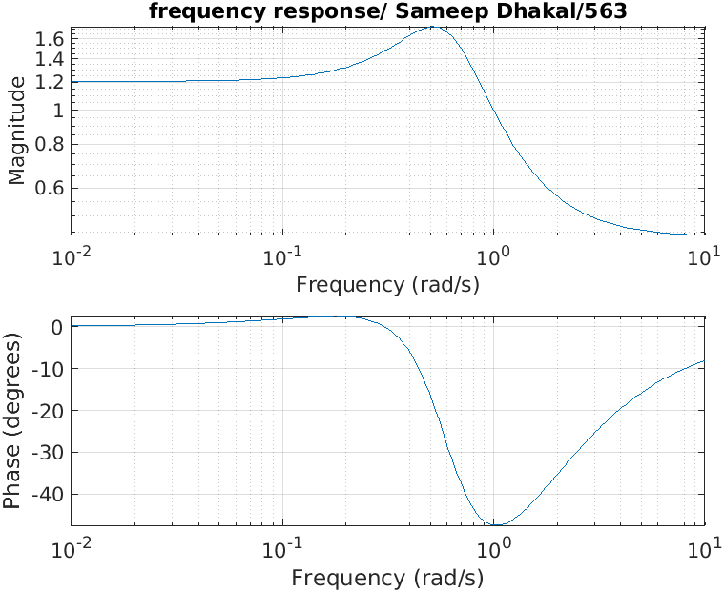

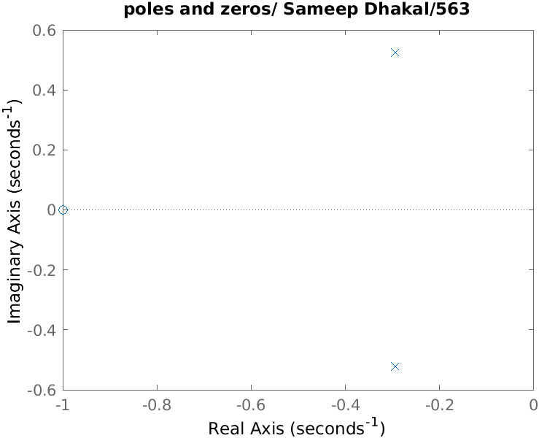

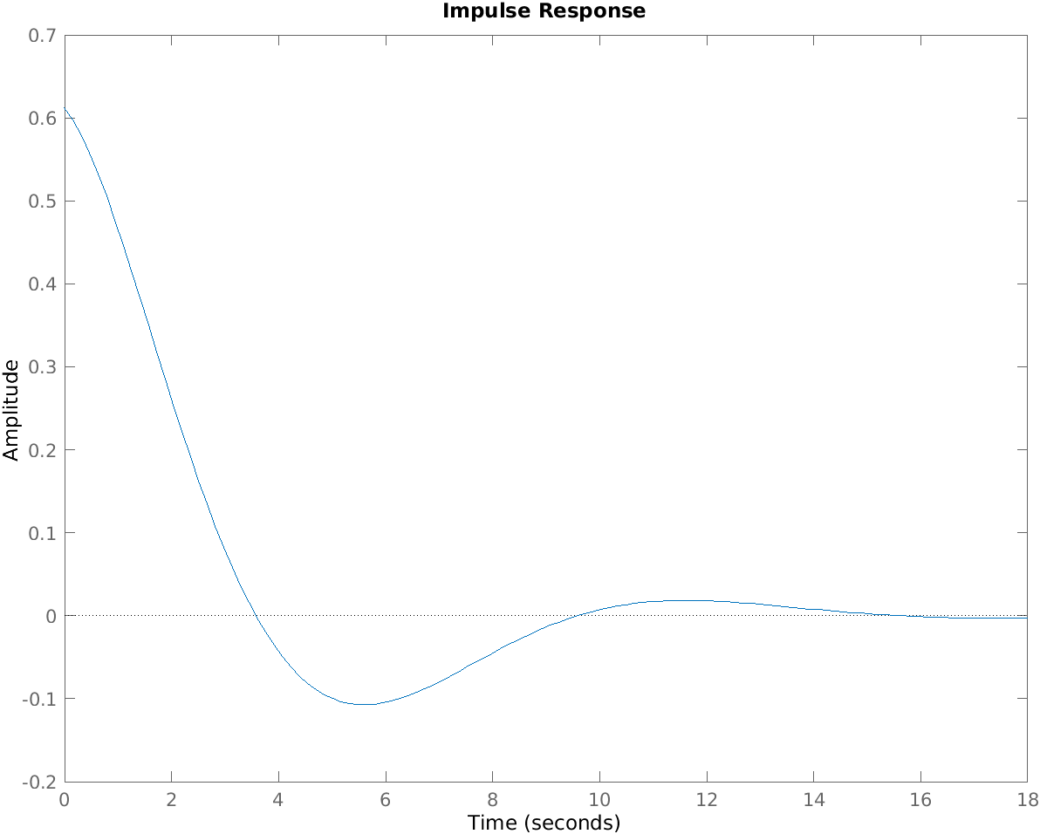

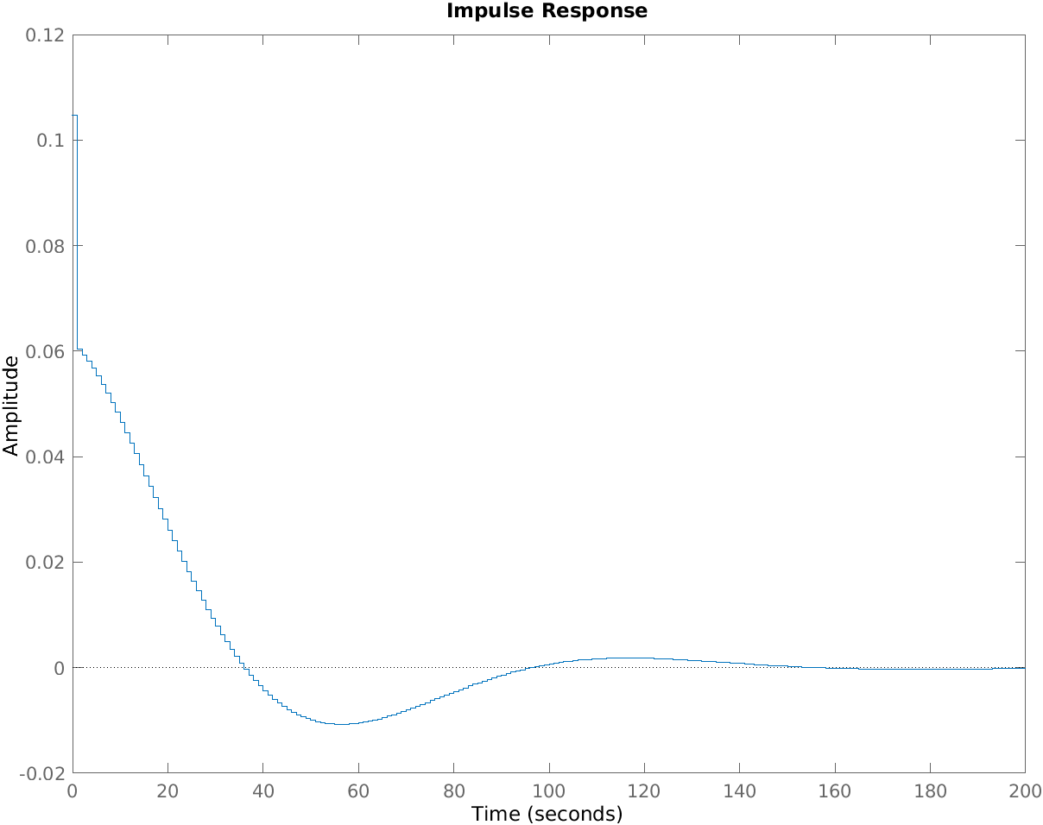

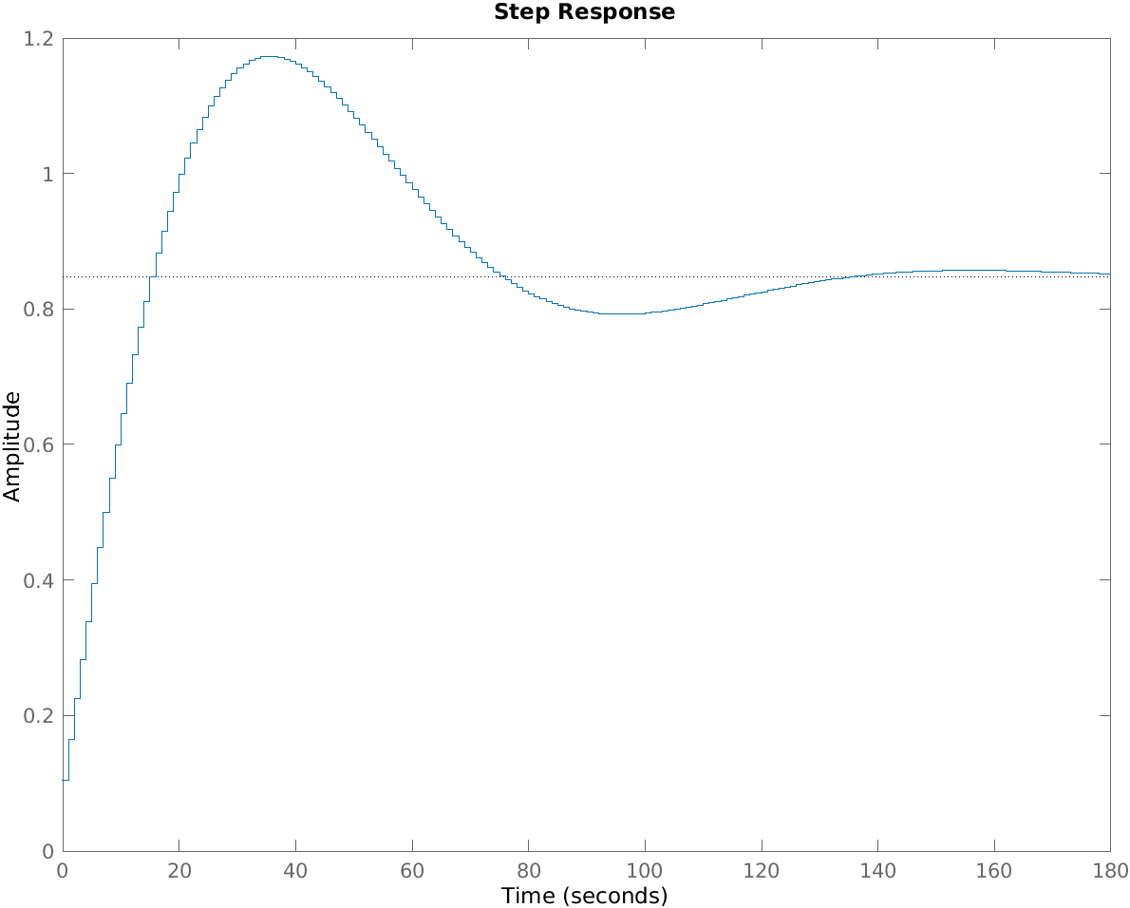

1. **Chebyshev II**

clc;

clear all;

close all;

wp= 0.2*pi;

ws=0.3*pi;

rp= 1;

rs= 15;

[n,wn]= cheb2ord(wp,ws,rp,rs);

[b,a]= cheby2(n,rs,wn);

sys= tf(b,a);

figure;

freqs(b,a);

title('frequency response/ Sameep Dhakal/563');

figure;

pzmap(sys);

title('poles and zeros/ Sameep Dhakal/563');

figure;

impulse(b,a);

[bz,az]= impinvar(b,a,10);

figure;

dimpulse(bz,az);

figure;

dstep(bz,az);

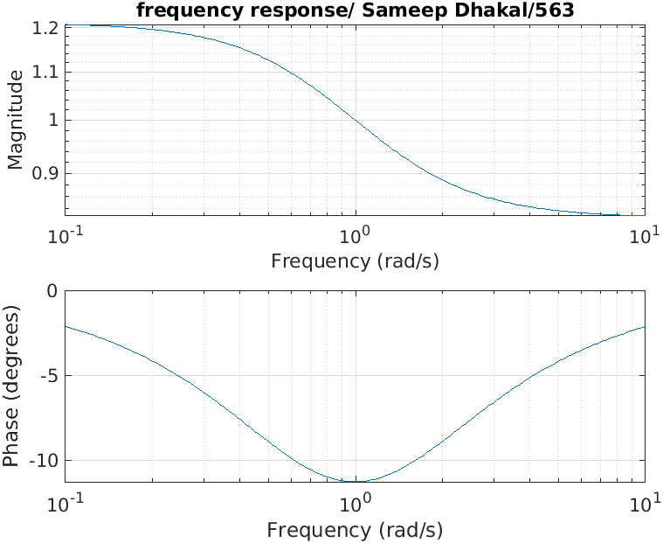

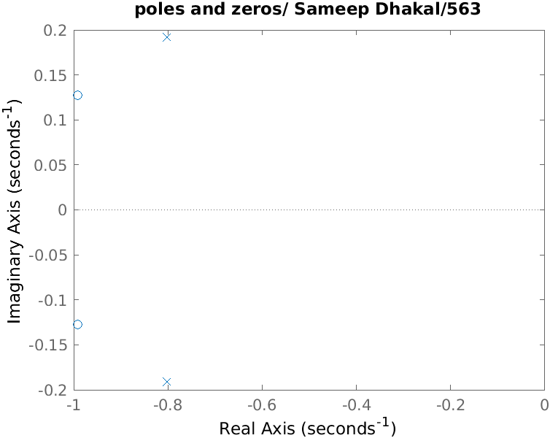

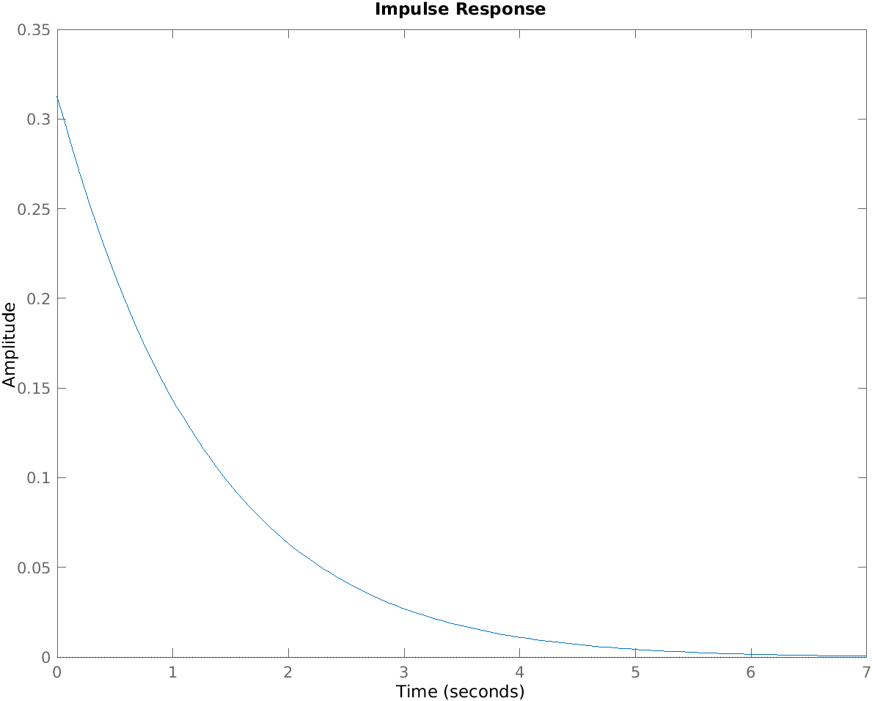

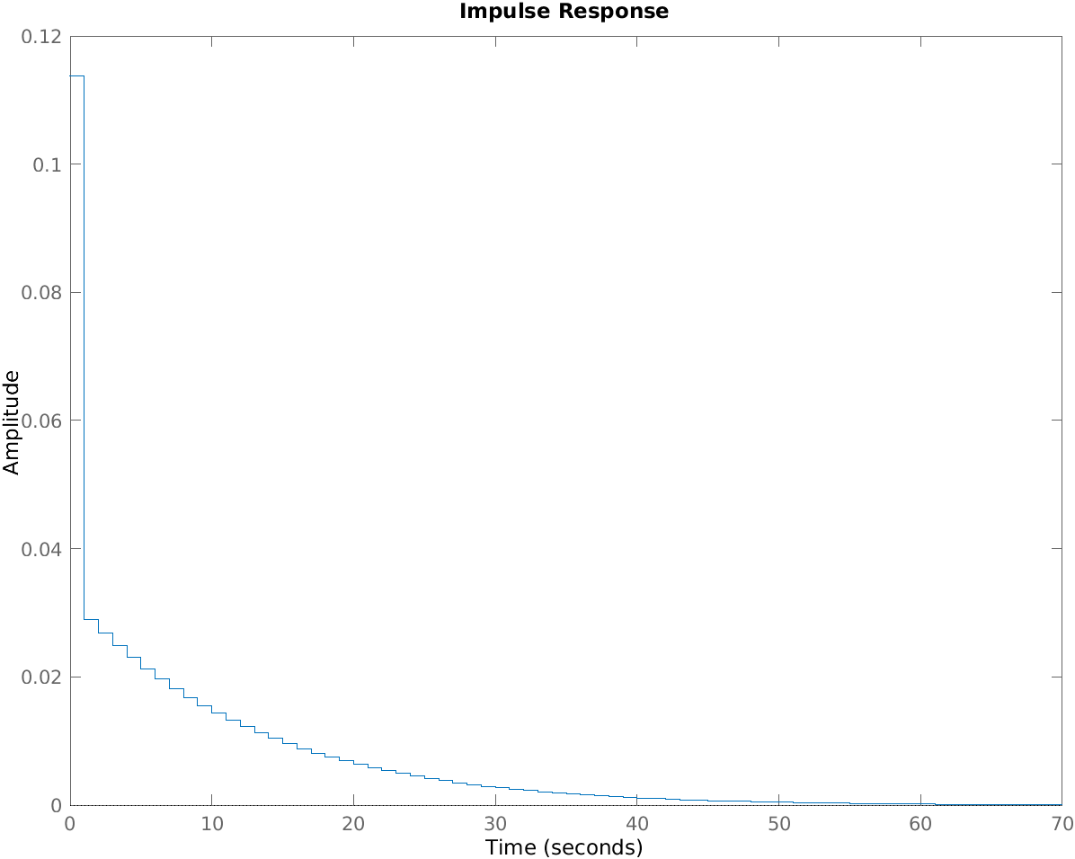

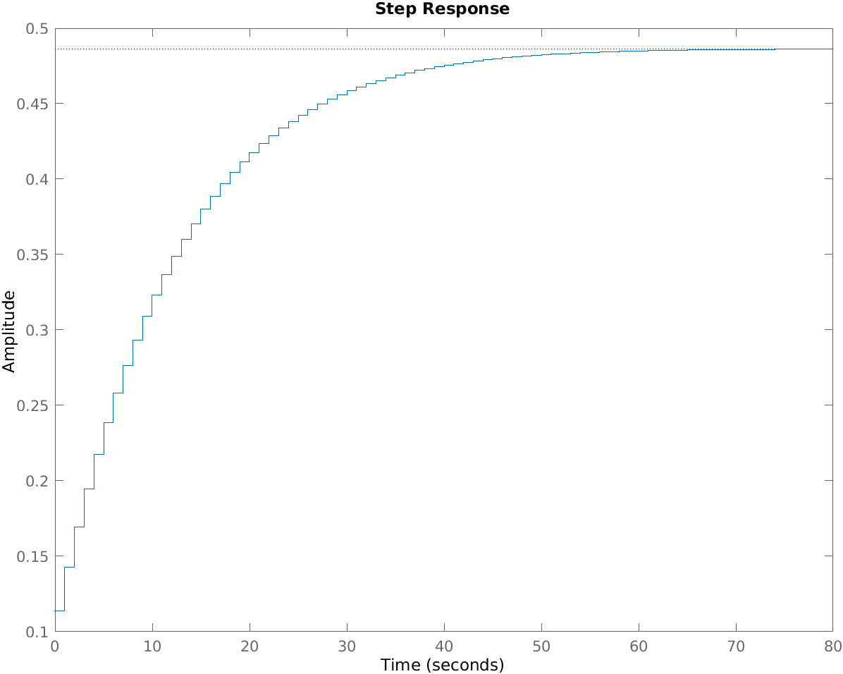

1. **Finite Impulse Response**

clc;

clear all;

close all;

fp=input('enter passband freq:');

fs=input('enter stopband freq:');

rs=input('enter passband attenuation:');

rp=input('enter stopband attenuation:');

f= input('Enter sampling freq:');

num= -20*log10(sqrt(rp*rs))-13;

dem= 14.6*(fp-fs)/f;

n= ceil(num/dem);

n=abs(n);

wp= 2*fp/f;

ws= 2*fs/f;

wn= (ws+wp)/2;

if(rem(n,2)==0)

m= n+1;

else

m=n;

n=n-1;

end

w=hann(m);

b=fir1(n,wn,'low',w);

freqz(b,1,500,3000);

title('Magnitude and phase response/ Sameeep Dhakal/563');

Input:

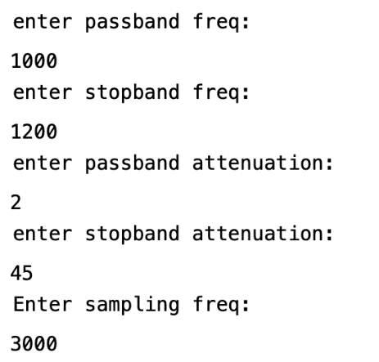

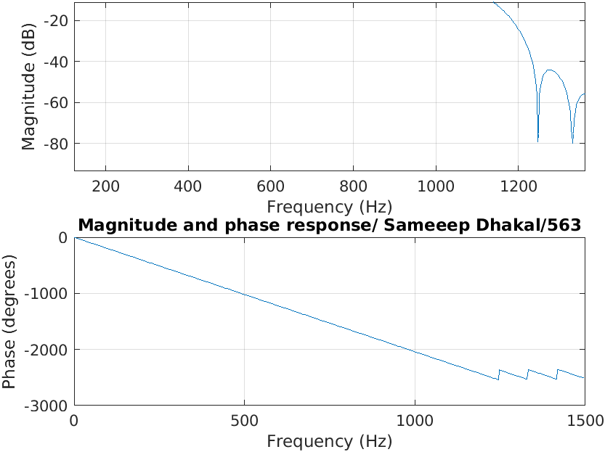

**DISCUSSION AND CONCLUSION:**

In this lab we worked on designing IRR filters and also low pass filters analyzed their output using matlab.